Instructions for Heat Stress Sign

Controls Display:
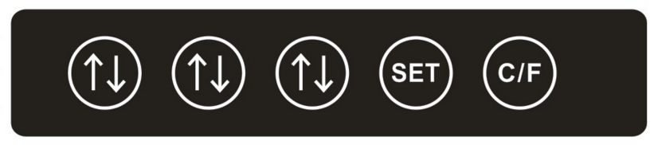

1. Instructions for use:
- Plug into any standard 110/120VAC outlet. If used outdoors, ensure the unit is plugged into a GFI outlet with a waterproof protective receptacle cover. Mount under protective overhang or covered area

- When the display is powered on it will show the actual temperature (when the actual temperature is lower than the warning temperature, the display will show green, if the actual temperature is higher than the preset warning temperature, the display will be in red)
- Select Celsius or Fahrenheit by pressing the button, this will control the current temperature and the warning temperature

2. Warning temperature setting:
- Press the , button, the system will go into setting mode, all numbers will flash
- Use the to set the temperature for each digit by cycling through the numbers
- Once the desired warning temperature is set, press to record the temperature

Your display is ready to use

